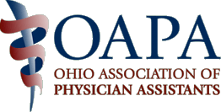
Region 1 & 2 Spring Social
Friday June 14, 2013
6:00pm - ?
- Please come join your fellow Physician Assistants at an informal social
- Appetizers and fountain drinks will be provided at no cost
at
Panini’s
5530 Brecksville Road
Independence, OH
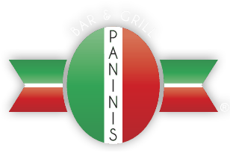
Please RSVP to Kristin Homoki: kristin.homoki@tri-c.edu

